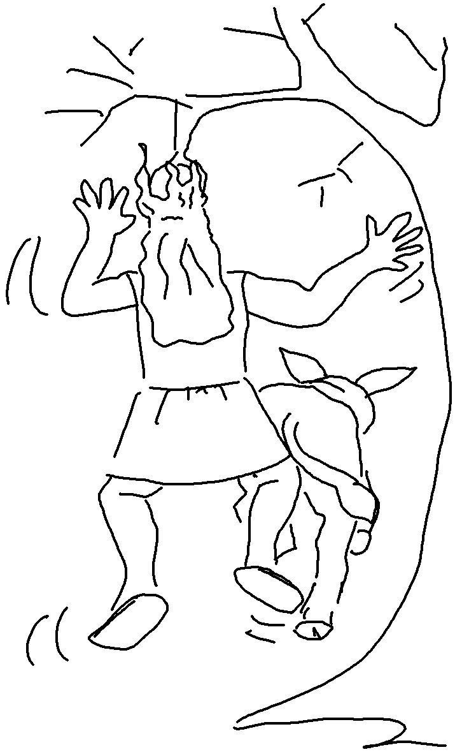

Children, obey your _ _ _ _ _ _ _ in the _ _ _ _, for this is right. "Honour your father and mother" — which is the first commandment with a promise. Ephesians 6:1, 2_{NIV}

